Environmental Modelling & Forecasting Workshop
The Alan Turing Institute – Wednesday 14th January 2026 – SPHERE-PPL
info@sphere-ppl.org

Agenda
Timings | Activity | Description
9:30-10:00 | Arrivals & Registration
10:00-10:15 | Introduction from the SPHERE-PPL Team | Meet the team and an introduction to the vision
10:15-10:40 | Keynote 1 - Dr Mark Ramsden | ADAS
10:40-11:00 | Keynote 2 - Dr Will Pearse | Imperial College London
11:00-11:30 | Coffee Break
11:30-12:15 | Break-Out Discussion | Identifying key environmental challenges
12:15-12:45 | Break-Out Feedback | 2-minute presentations on challenges
12:45-13:45 | Lunch
13:45-13:55 | Presentation | Building a Forecasting Contest
13:55-14:30 | Break-Out Design | Groups design forecasting contests
14:30-15:00 | Break-Out Feedback | Group feedback and discussion of contest priorities
15:00-15:30 | Coffee Break
15:30-15:40 | Presentation | What can SPHERE-PPL do for you?
15:40-16:00 | Break-Out Discussion | Brainstorming requests for workshops, training and support
16:00-16:30 | Break-Out Feedback | Creating a community priority list
16:30-17:00 | Wrap-Up

WiFi
Network: Turing Guest
Password: clicking seventh void compiled (Password contains spaces)
Eduroam is also available

Resources
Event Page: https://sphere-ppl.org/Annual-Meeting-Jan26/
Mural Board: https://shorturl.at/carOR or follow the link on the Event Page

Facilities
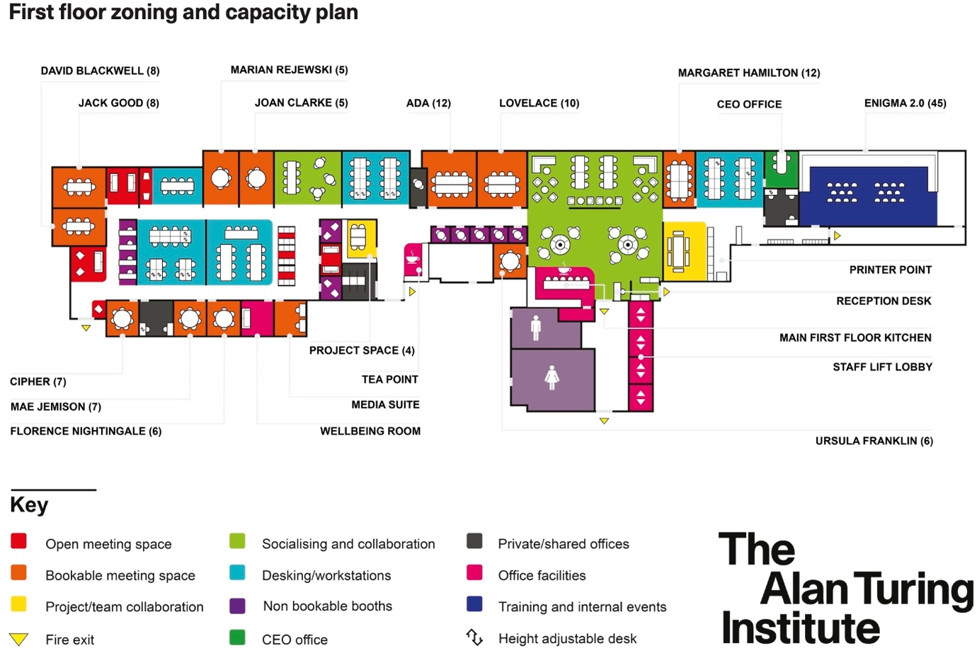

Code Of Conduct
- Respectful Communication: Communicate with others in a professional and considerate manner. Be mindful of diverse perspectives and experiences. Avoid interrupting others and listen actively.
- Inclusive Language: Use inclusive language that avoids any discriminatory or offensive remarks. Be mindful of gender, race, ethnicity, religion, sexual orientation, and other personal attributes.
- Active Participation: Engage actively in discussions and activities. Share your insights and perspectives while being mindful of others' contributions.
- Professional Conduct: Maintain a professional demeanour throughout the workshop, including during breaks and social events.
- Mobile Devices: Minimize distractions by silencing mobile phones or using them only during breaks, unless they are essential for workshop activities.

